Sub Area and Neighborhood Plans Table of Contents

Suquamish 2

Vision for Suquamish 2

Suquamish Goals and Policies 4

Kingston 8

Vision for Kingston [placeholder] 8

Kingston Goals and Policies 9

Manchester 16

Vision for Manchester 16

Manchester Goals and Policies 17

Silverdale Sub Area Plan 22

Vision for Silverdale Sub Area 22

Silverdale Sub Area Plan Goals and Policies 24

Silverdale Regional Center 30

Overall Vision for Silverdale Regional Center 30

Silverdale Regional Center Goals and Policies 32

llahee 42

Vision for Illahee 42

Illahee Goals and Policies 43

Keyport 46

Vision for Keyport 46

Keyport Goals and Policies 47

Suquamish

• • •

Vision for Suquamish

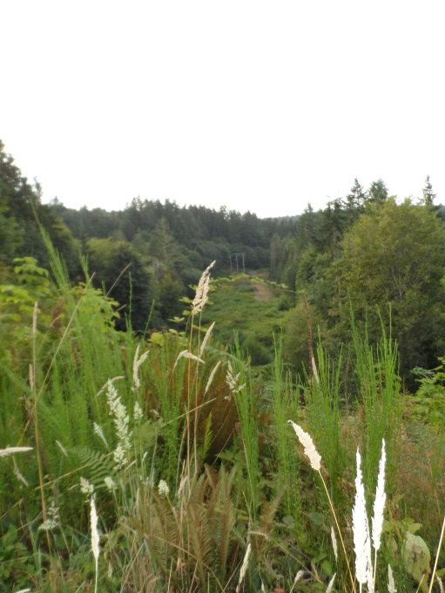Suquamish is a rural, historic waterfront community on the Port Madison Indian Reservation, which is defined by strong natural borders in northeast Kitsap County. The Port Madison Indian Reservation is located on the western and northern shore of Port Madison Bay. The reservation also fronts Agate Pass on the western side. Bainbridge Island is located on the eastern side of the Pass. The Agate Pass Bridge connects Bainbridge Island with the Reservation on the Kitsap Peninsula.

Increased growth pressures are threatening the Suquamish Village’s natural boundaries. Increased development was beginning to exceed the capacities of the infrastructure systems. Transportation infrastructure and drainage systems were no longer adequate, open space diminished and the rural character of the town changed. Tribal members living in Suquamish and non-Indian residents who moved to Suquamish for its rural qualities and remote location found their chosen lifestyle at risk. However, any vision for Suquamish must balance the preservation of the rights of Tribal members and of non-Indian property owners to enjoy the reasonable use of their land.

The Suquamish Village will make its visitors feel welcome, but not rely solely on tourism as a mechanism for economic health. Economic and cultural diversity shall be celebrated and enhanced for the benefit of all residents of Suquamish. The Suquamish Village’s native Indian history and presence shall be enhanced and remain a visible part of the Suquamish experience.

The downtown should remain the heart of Suquamish where residents and visitors will gather together to celebrate traditions and experience daily living. Suquamish will offer small business districts for small-scale neighborhood convenience stores or public services.

It shall become a community where one can enjoy its open spaces and recreational opportunities as well as safe and pleasurable walks along a system of public roadways, which link the neighborhoods to each other and to the commercial districts. The Suquamish Rural Village shall welcome all social and economic groups. It shall provide a sense of community, and the Tribe and the County shall work cooperatively.

Suquamish Goals and Policies

Capital and Economic Development

**Suquamish Goal 1. Establish a Kitsap Regional Library Extension.**

1. Examine prospective locations for a Kitsap Regional Library (KLR) extension in coordination with KRL, Kitsap County, and the Suquamish Tribe to establish a library with suitable amenities (Wi-Fi, computer access, and other access).

**Suquamish Goal 2. Provide Transportation Improvements that Enhance Economic Development.**

1. Conduct studies to maximize the effectiveness of Suquamish downtown parking, traffic, land use and potential aesthetics.

**Suquamish Goal 3. Establish a Suquamish Aesthetic beneficial to Economic Development.**

1. Determine what a Suquamish downtown (Augusta Avenue and Suquamish Way) aesthetic would look like (signage, street lights, storefronts, public art, etc.) and further define action required to achieve that aesthetic to include:

* Signage to meet the Suquamish aesthetic, including welcoming sign and street signs.
* Implement utility improvements, including street lighting that would support economic development.
* Examine the feasibility and implement appropriate trash can placement (and supporting solid waste removal)

1. Collaborate with Suquamish Tribal Government, Port Madison Enterprises, and other business district interests to examine and support zoning and construction encouraging first floor storefronts with affordable second floor living options.

**Suquamish Goal 4. Support Information Sharing and Information Access in Suquamish.**

1. Examine, and if feasible implement, a Public Wi-Fi access capability.

Transportation (Roads, Walkability, and Bicycling)

**Suquamish Goal 5. Evaluate changes for Augusta and Suquamish Way to allow for safe and effective access to businesses.**

1. Examine, and if feasible implement, a three lane corridor along Augusta Avenue starting at NE Geneva Street and continuing up Suquamish Way to Division [in vicinity of the Suquamish Village] to enhance current and future Suquamish economic development and access.

**Suquamish Goal 6. Improve parking to support safe business access.**

1. Improve parking along, or in vicinity of, Augusta Avenue starting at NE Geneva Street and continuing up Suquamish Way to Division to enhance current and future Suquamish economic development and access.

**Suquamish Goal 7. Develop walkways, crosswalks and bicycle routes that enhance the walkability, safety and economic development of Suquamish.**

1. Provide walkways and crosswalks extending on Augusta Avenue from NE Geneva Street to Suquamish Way to enhance current and future Suquamish economic development and access.



1. Examine, and if feasible implement, walkways and crosswalks on Division Ave NE and NE McKinstry St. (starting at Suquamish Way) to provide a safe and walkable access to the Sports Court Park and the historically significant Old Man House Park.
2. Provide a pedestrian connection between Suquamish and the network of trails within the Cowling Creek Preserve, which with additional development could serve as a bike route bypassing a portion of Miller Bay Road with no shoulders.
3. Examine, and if feasible implement, paving the shoulders of Miller Bay Road from NE Geneva St. to Gunderson Rd. thereby providing the first/only safe route for walkers, joggers or bicyclists to enter and depart Suquamish to the north towards Kingston.

**Suquamish Goal 8. Evaluate road safety improvements in and around Suquamish.**

1. Examine, and if feasible implement, speed controls and widening/paved shoulders on NE Columbia Street to increase safety as the alternate northern route out of Suquamish.
2. Examine, and if feasible, due to existing zoning and road width constraints, implement one-way traffic options on Geneva and Center Streets.

Parks and Open Space

**Suquamish Goal 9. Coordinate efforts among the community, the Suquamish Tribe and the County to maintain existing Parks within and surrounding Suquamish to their fullest potential.**

1.  Where consistent with CFP resurface the Sport Court at NE Division Ave and McKinstry St. for increased safety and use.
2. Provide and enhance access and kayak launches at appropriate County rights of way throughout Suquamish (i.e. Hemphill Rd. terminus, or southwest terminus/right of way NE Angeline Rd.)
3. Improve park maintenance.
4. Examine and if feasible implement watering capability to Angeline Park and the Sports Park for maintenance of the plant beds.
5. Implement upgrades and improvements to the Angeline Park playground.

**Suquamish Goal 10. Partner with the Suquamish Tribe to discover new opportunities for desired Parks/Open Spaces.**

1. Examine, and if feasible create, an off-leash dog park.
2. Examine, and if feasible create, a Skateboard park.
3. Examine, and if feasible create, a Community Garden.

**Suquamish Goal 11. Public Restrooms**

1. Collaborate with Suquamish Tribal Government to establish public restrooms near the Suquamish Dock.

Stormwater and Sewer

**Suquamish Goal 12. Continue Suquamish Stormwater and Sewer Improvements**

1. Support development of a comprehensive and natural approach to stormwater management to implement projects to control flows, reduce flooding, and enhance water quality. The Suquamish Community Advisory Council will examine, and if feasible support and endorse community concerns as they arise.

Kingston

• • •

Vision for Kingston [placeholder]

Kingston Goals and Policies

Economic Development

**Kingston Economic Development Goal 1. Within the Kingston UGA, support the establishment of locally-owned businesses, cottage industries and home businesses.**

1. Encourage the development of state-of-the-art telecommunication infrastructure to serve the Kingston UGA.
2. Continue to allow home office businesses within the Urban Village Center zone.

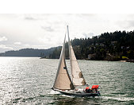

1. Collaborate with the Kingston Chamber of Commerce, the Kitsap Economic Development Alliance (KEDA), Public Utilities District, and the Port of Kingston and other organizations to foster and promote an information system infrastructure and promote a business atmosphere that encourages and supports technology-based industry.

**Kingston Economic Development Goal 2. Support the maintenance of local businesses.**

1. Investigate feasibility of using a rolling type "multi-year" permit process for event venues for appropriate locations.
2. Work to streamline regulations to encourage agritourism.
3. Encourage compact residential development in the downtown core as defined by Urban Village Center, Neighborhood Commercial and Highway/Tourist Commercial zones.
4. Encourage development that build projects compatible with Kingston's current design.
5. Encourage small business development and business incubators.

**Kingston Economic Development Goal 3. Support tourism to enhance the local economy.**

1. Support the development of bed and breakfasts and small lodging venues in the Kingston area.
2. Facilitate the development entry/exit signage consistent with area identity.
3. Facilitate the development of a downtown way-finding system consistent with area identity.

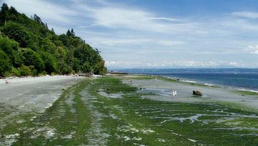

1. Foster partnerships with the North Kitsap Tourism Coalition, Visit Kitsap, the Port of Kingston, the Kingston Chamber of Commerce, the Greater Kingston Economic Development Committee and other organizations to promote tourism and business development.

Environment

**Kingston Environment Goal 4. Protect and work to restore wildlife habitat, marine shorelines, and other natural areas around Kingston.**

1. Support community work with non-profit groups to acquire land for conservation and preservation of wildlife habitat.
2. Participate in the West Sound Watersheds Council and support Puget Sound Salmon Recovery programs.
3. As feasible, acquire shoreline property and investigate easements in Kingston for public stewardship and habitat protection.

**Kingston Environment Goal 5. Coordinate an integrated network of spaces that could expand recreational opportunities for both residents and visitors, and takes advantage of Kingston’s visual amenities and natural environment.**

1. As feasible, work with non-profit groups to acquire land for open space conservation and trails network.

Parks, Trails and Open Space

**Kingston Parks, Trails and Open Space Goal 6. Encourage participation of community organizations and residents in the planning, development and authorized use of parks, community facilities, libraries and senior centers.**

1. Consult with the community organizations and residents concerning the disposition or repurposing of public land and facilities that have parks, trails and recreation potential.
2. Coordinate with other local jurisdictions, community organizations and residents in developing long range plans, budgets and usage regulations for public facilities, parks and open space.

**Kingston Parks, Trails and Open Space Goal 7. Pursue the creation of a more walkable community by supporting development of pedestrian pathways, sidewalks and trails that connect people to places.**

1. [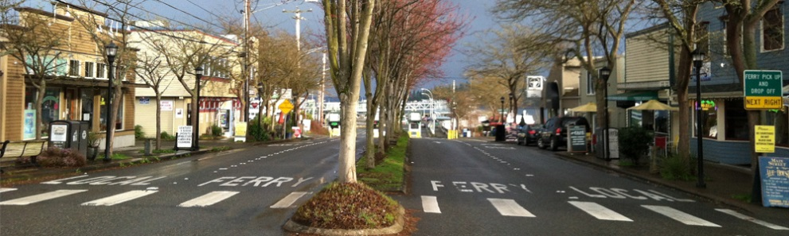](http://compplan.kitsapgov.com/MainSlider/Forms/DispForm.aspx?ID=10&RootFolder=/MainSlider) As feasible, support recommendations identified in the Kingston Trails Plan.
2. Coordinate with state, Tribal, and non-governmental groups and Kingston residents to acquire land for trails, community connectors and open space corridors.
3. Coordinate maintenance and operation support for parks, trails and open space with other jurisdictions and supporting community groups.
4. Encourage Kingston residents to review budgets for Parks, Recreation and Open space for the Kingston area.
5. Coordinate with the local jurisdictions, state agencies, and community groups to create and enhance water related recreation, facilities and public access.
6. Safety and security shall be considered when reviewing plans for trails, pathways, and greenways to connect parks, shoreline and recreational resources throughout the Kingston area.
7. Encourage the establishment of a trails system sign program that identifies access points and destinations.

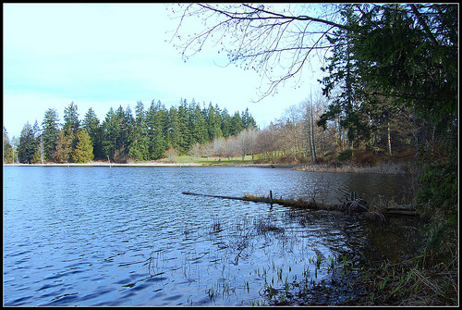**Kingston Parks, Trails and Open Space Goal 8. Create bicycle routes, multiuse pathways, and bike storage facilities to provide safe, secure and efficient bicycle connections for commuter, visitor, fitness and recreational riders.**

1. Consult and coordinate with Kingston area community groups to define, and prioritize Kingston area bike routes.
2. Ensure that local bike routes connect with regional bike routes.
3. Support and promote the Kitsap Peninsula Water Trail.
4. Coordinate with state agencies and community organizations to ensure that public use of tidelands and public waterfront property protects water quality and sensitive areas while also allowing for public recreation.

**Kingston Parks, Trails and Open Space Goal 9. Provide and maintain Parks and Fields and community facilities to support sports, recreational, educational, and social activities for the community.**

1. Consult with state agencies and local jurisdictions to provide parks, open space, fields, and facilities that support active and passive recreation.
2. Encourage public participation in development of plans for maintenance and operation for parks, open space, fields, and facilities in the Kingston area including volunteer efforts.
3. Encourage public participation of community organizations and residents in the planning, development, operation, authorized use and maintenance of parks, trails, community facilities, libraries, sports fields and senior centers.

Transportation

**Kingston Transportation Goal 10. Work with WSDOT to attempt to reduce traffic issues.**

1. Encourage WSDOT to reduce the back up of queued ferry traffic in downtown Kingston and optimize the use of the ferry holding lot.
2. Encourage WSF to provide a third overflow ferry boat during periods of high ferry demand and ferry wait times.
3. Encourage WSDOT to pursue the rerouting of ferry traffic to the present outbound ferry traffic lane and investigate of the feasibility of using the current WSDOT parking lot as auxiliary holding area.

**Kingston Transportation Goal 11. Enhance the aesthetic values of the streetscape in Kingston as identified in the *Kingston Complete Streets* study.**

1. 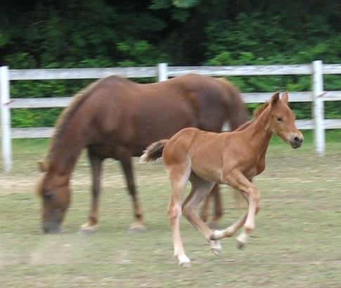 Within the Kingston UGA, ensure the design standards are followed.
2. Consider updating the Kingston Design Standards with focus on aesthetics of streets, sidewalks, and associated amenities.

**Kingston Transportation Goal 3. Work to improve safety for pedestrians, bicycles, and vehicles within the Kingston Urban Growth Area.**

1. Encourage connectivity between developments.
2. Coordinate with WSF to improve pedestrian and bicycle access to the ferry dock.

**Kingston Transportation Goal 12. Work to ensure that an appropriate balance of long-term and short-term parking is available in the downtown area.**

1. Through public-private and public-public partnerships, review the existing public parking availability, and accessibility within Kingston.
2. After public parking availability and accessibility study is complete, consider updates or changes to parking requirements relating to occupancy in the Kingston UGA.
3. As feasible implement incentive based parking programs within the Urban Village Center Zone, such as shared-use parking and on street parking.

Community

**Kingston Community Goal 13. Formalize Kingston community identity.**

1. Locate community-oriented public facilities within the UGA.
2. 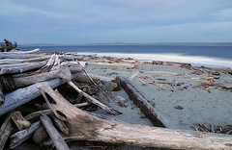 Work with the community to consider preservation and highlighting of the historic features and characteristics of Kingston in community planning and development, and design standards.
3. Preserve the small town character of the Kingston UGA in community planning and development.
4. Work with Kingston Community Advisory Council to support ongoing efforts to provide severe weather shelter services and/or warming station in public buildings.

Land Use

**Kingston Land Use Goal 14. Involve the Kingston community input when proposing development regulations.**

1. Review mixed use standards for Urban Village Center and amend as necessary.
2. Increase residential density allowance in Urban Village Center.
3. Support the community to the extent feasible in their aspiration to identify view corridors while balancing the rights of private property owners.

**Kingston Land Use Goal 15. Apply Kingston Design Standards in the permitting process.**

1. Explore new code provisions to support redevelopment.
2. Update Kingston Downtown Design Standards to address ongoing public input.
3. Prioritize the required infrastructure to encourage urban medium and high density residential uses near commercial areas and public spaces.

Manchester

• • •

Vision for Manchester

The Manchester Community Plan is a statement of the community values and aspirations for the future. This is an effort to recognize what originally attracted visitors in the past combined with a phasing process of improvements to enhance the atmosphere and visual character of the area.

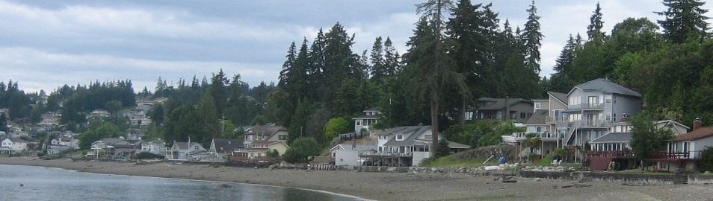When posed with the question, “What would the perfect Manchester look like?” residents envisioned a village center that acts as a social center with restaurants and cafes, augmented by a food or general store to provide basic needs. It would strive to maintain the small-town charm and quaintness that Manchester currently offers. Of parallel importance is the preservation of the spectacular views of the Puget Sound, the cosmopolitan city of Seattle, Cascade mountain ranges, and the breathtaking view of Mount Rainier. Residents wish to maintain and enhance their high quality of life as well as the quality of the natural environment. Protection of wetlands, streams and wildlife habitat is highly emphasized. This can be accomplished by permitting growth that provides infrastructure enhancements and environmental protections while maintaining Manchester’s Village atmosphere for visitors and a safe and inviting home for residents. Manchester Goals and Policies

Manchester Goals and Policies

Public Participation

**Manchester Goal 1.** **Increase public participation in the implementation of the Manchester Community Plan.**

1. Use the Manchester community website and vehicles such as: Manchester Days, community activities (such as tree lighting) and the Manchester Community Association’s educational programs.

Zoning and Development Regulations

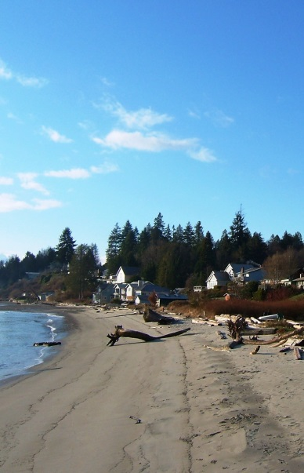**Manchester Goal 2. Maintain and manage growth, density, zoning, and land use consistent with the requirements and policies of the Manchester LAMIRD**

1. Maintain maximum height limits feet consistent with Manchester view protection overlay
2. Maintain and enforce existing code regarding legacy and nonconforming lots, according to Section 2.23 in the Manchester Plan Update.
3. Review cluster development as it applies to the Manchester LAMIRD.
4. Protect Manchester’s existing views including but not limited to Mt. Rainier, the Cascade Mountain Range, Puget Sound and the Seattle skyline by addressing vegetation height and density regulations.

Environment

**Manchester Goal 3. Protect and enhance the shoreline resources that add to the unique character of the Manchester LAMIRD.**

1. Coordinate with Port of Manchester to achieve a balanced use of their public shoreline facilities to create minimal environmental impact.
2. Educate the public on issues of wildlife habitat, critical area and shoreline protection, stormwater management and air quality.
3. Create a plant list that includes native, water retaining, non-invasive, and height-limited vegetation, to encourage replanting native tree and plant species on all properties.

Transportation

**Manchester Goal 4. Provide the citizens the opportunity to participate in the development of transportation planning policy regarding street designs and development patterns that accommodate pedestrians, vehicles, transit users and bicyclists in a balanced way.**

1. All future County projects including but not limited to Beach Dr., Colchester Dr., Chester Rd., Main Street, Madrone Street, Alaska Avenue and California Avenue, should include continuous paved walkways for pedestrian use. These walkways should be coordinated with the Mosquito Fleet Trail Plan and/or the non-motorized trail plan.
2. Involve the Manchester Community Advisory Council in the Kitsap County Public Works transportation improvement planning (TIP) process to provide input for and act on all public works plans that affect the Manchester LAMIRD.

**Manchester Goal 5. Encourage the use of good design practices to reduce accidents and potential accidents by providing a safe transportation system.**

1. Any traffic analysis done in the LAMIRD should be conducted during peak traffic hours and peak recreational hours, or as applicable to the specific proposal.
2. 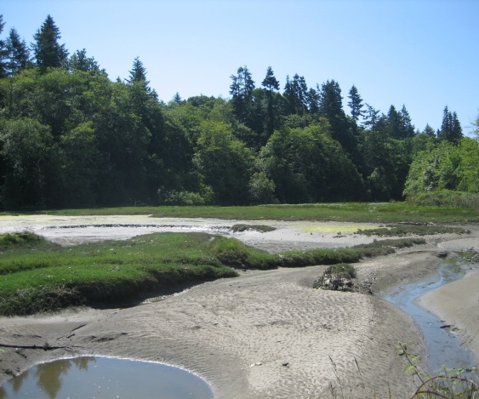All parking lots in the Commercial District should incorporate separate entrance and exit lanes where possible. .
3. Increase available parking in the Manchester Village Commercial district by ensuring all new development in the Manchester Village Commercial district provides parking consistent with the Manchester Design Standards (see Appendix A in the Manchester Community Plan).

Capital Facilities and Utilities

**Manchester Goal 6. Provide the availability of sewer service to all residents within the Manchester LAMIRD boundary without expansion of the existing sewer treatment plant.**

1. Provide education to property owners on benefits to having sewer connection

**Manchester Goal 7. Ensure expansion of the existing sewer distribution system to all properties within the Manchester LAMIRD boundary through the formation of utility local improvement districts (ULIDs).**

1. Require property owners on shorelines or near other critical areas to connect to the sewer system as required by the Kitsap Public Health District, if their current system has failed.

**Manchester Goal 8. Support development of a comprehensive approach to stormwater management that encourages coordination between Transportation, Wastewater, Stormwater and private development projects.**

1. Involve the Manchester community in the assessment and prioritization of stormwater capital facility projects.
2. Continue to identify areas needing improved stormwater infrastructure within Manchester.

**Manchester Goal 9. Ensure stormwater management systems that utilize and preserve natural drainage systems, such as streams, and construct facilities that complement these systems by taking advantage of opportunities for filtration, infiltration, and flow control where feasible and reasonable.**

1. Require the use of permeable surfaces and other Low Impact Development technologies in new building construction and property development.
2. Mitigate impacts of stormwater management regulations on private property owners by hosting meetings with the community when new regulations are proposed.
3. Determine cumulative impacts of development on surrounding properties, and minimize negative consequences of stormwater runoff on properties.

**Manchester Goal 11. Work with Kitsap Public Health District and Kitsap Sewer Utility to establish clear communication between government agencies as it relates to septic and sewer issues.**

Public Facilities and Parks

**Manchester Goal 12. Ensure public participation for all future improvements to public facilities and parks within the Manchester LAMIRD.**

1. Develop strategies for upholding private property rights while accommodating the public’s interest in experiencing the waterfront, views and recreation.

**Manchester Goal 13. Maintain current public facilities.**

1. Coordinate with the Friends of the Manchester Library, the Manchester Foundation Board, and the Port of Manchester Commissioners and Kitsap County concerning any development plans for public facility improvements and additions.

**Manchester Goal 14. Plan for a community center within Manchester.**

1. Continue working with groups, agencies, non-profits and citizens to secure funding and land for a future community center building.

**Manchester Goal 15. Expand walking and biking paths.**

1. Develop public right-of ways for the purpose of creating trails and providing foot access along and between the main thoroughfares to connect with Mosquito Fleet Trail and Kitsap Peninsula Water Trails.
2. Create a walkability map of the Manchester LAMIRD

Silverdale Sub Area Plan

• • •

Vision for Silverdale Sub Area

Land Use - Within the UGA, Silverdale has a mix of residential development, commercial centers and light industrial areas that serve the housing and employment needs of the community. These areas are integrated with the natural amenities of the landscape, including the striking views of mountains and water, and access to open space, maintaining Silverdale’s high quality of life. Community gathering places, which provide local shopping, services and opportunities for recreation, are interspersed throughout the area and are connected through pedestrian-friendly trail and path systems. Through the application of urban design guidelines, the unique characteristics of existing districts are preserved and identities for new development are fostered.

Economic Development -Our status as a regional retail and service center is complemented by the expansion and diversification of our economic base, particularly through expansion of wealth generating businesses, as well as through development of educational opportunities.

Transportation -We have a transportation system that will properly support community and residential needs. We have a multimodal circulation system; it accommodates transit, bicycles, pedestrians and autos. There are many options for getting into, out of and moving within the urban growth area, and bypassing the urban core. Downtown circulation is improved, we have a walkable environment and our grid system is expanded.

Housing -Our community provides a wide choice of housing types and prices -- accommodating a diversity

of lifestyles and incomes. New residential development is centered in mixed income neighborhoods that are safe and secure. Each neighborhood has a character of its own and includes a mix of uses that provide opportunities for localized services and recreation close to home. We respect existing neighborhoods; their character is key to the long-term sustainability.

Governance -Within the 20-year planning horizon, Silverdale will be a self-governing city.

Social Capital -We have diverse opportunities for arts, recreation, entertainment, leisure activities and culture; activities we can “do” are continuously being created

Capital Facilities -We have the public facilities to support a vibrant and growing city.

Natural Environment -We have tremendous natural resources and amenities. We are sensitive to our existing natural systems– maintaining, protecting and conserving them in a way that is sensitive to their environmental functions, particularly Dyes Inlet watersheds and water quality and aquifer recharge areas. We are rich in significant, pristine resource areas.

Silverdale Sub Area Plan Goals and Policies

Land Use

1. **Provide sufficient capacity within the UGA to properly accommodate a mix of residential, commercial, and industrial development to meet the extended population and employment projections for Silverdale.**
2. Monitor land supply over time to ensure a continued adequate supply of residential, commercial and industrial designated land to meet Silverdale’s population and employment targets and to meet the needs of unanticipated growth.
3. In establishing and modifying land use designations, provide for a balanced and complete community that allows for a future self-governing jurisdiction i.e. incorporation.
4. Incorporate reasonable measures that are appropriate to the Silverdale area to help focus growth in the urban growth area. These measures could be incentives, standards, policies, and/or regulations. In this Sub-Area Plan, incorporated reasonable measures include:

* Inclusion of an economic development plan element intended to encourage employment and related housing/population growth in the UGA;
* Support the Silverdale Regional Plan goals and Policies

1. In areas where pedestrian and/or bicycle activity is desired, such as in Old Town, in new mixed use centers, and within residential neighborhoods, provide sidewalks, trails, landscaping, crosswalks, to increase opportunities for walking and bicycling.
2. In areas where vehicular transportation will continue to be the predominate mode of travel, ensure that access to rights-of-way and site design standards provide for safe and convenient access by the traveling public.
3. Locate industrial and regional commercial land use designations in areas with safe and direct access to arterials and freeways.
4. **Provide land availability for public and private community**

**gathering places and diverse opportunities for arts, recreation,**

**entertainment, leisure activities and culture.**

1. Support design standards that encourage provision of plazas, greens or other informal public meeting spaces with new development.
2. 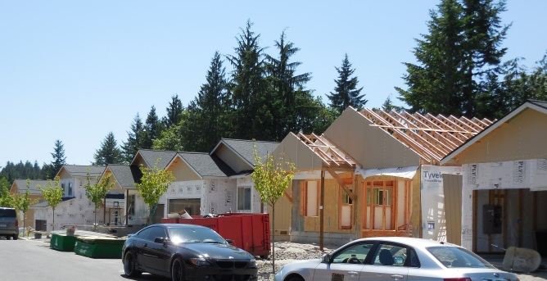Preserve and enhance the natural and aesthetic qualities of shoreline areas and riparian creek corridors while allowing reasonable development to meet the needs of property owners.

Economic Development

1. **Enhance the status of Silverdale as a regional retail and service**

**center.**

1. Develop and implement an economic development program that encourages the location of businesses in the downtown core and actively seeks opportunities to strengthen the regional role of the retail and service center.
2. Encourage the cooperation and collaboration of agencies and interested groups in marketing the Silverdale areas to attract new business.
3. Encourage and support tourism activity as a significant contributor to the Silverdale economy.
4. **Achieve diversification of Silverdale’s economic base, particularly through expansion of wealth generating businesses and higher educational opportunities.**
5. Facilitate the diversification and growth of the Silverdale area economic base through a range of appropriate commercial land use designations, adequate land supply, improved transportation infrastructure, active business recruitment, and business friendly policies and regulations.
6. Actively recruit educational institution to the Silverdale area.
7. Identify and encourage business opportunities that may benefit from the geographic proximity of existing military facilities.
8. **Support and coordinate economic expansion through efficient**

**use of land and provision of capital facilities.**

1. Encourage full use and development of designated commercial and industrial areas prior to expanding those areas. Promote revitalization within existing developed areas to take advantage of the investment in existing buildings and infrastructure.
2. Provide incentives for re-use or redevelopment of existing commercial facilities in preference to building of new space.
3. Provide adequate transportation infrastructure to serve a diverse range of commercial activity.
4. Work to meet unique transportation needs of new or growing businesses.
5. **Support commercial development that complements and is compatible with the larger Silverdale community.**

Housing

1. **Promote and protect the long-term viability, safety, character and identity of existing neighborhoods.**
2. Identify opportunities for community services and general recreation facilities within or between residential neighborhoods, with strong emphasis on private development and maintenance by neighborhoods.
3. Work with neighborhoods to identify key landmarks, boundaries, gathering places, significant natural features, existing and potential pedestrian routes, neighborhood gateways, and other features that help identify and establish their unique character.

Transportation

1. **Develop and maintain a street and transportation system that effectively addresses the travel needs of the community and is consistent with the overall goals of the community.**
2. Consider Trigger Avenue extension to provide ease of access to north Silverdale to Highway 3.
3. Develop and maintain performance standards, including operational level of service (LOS) standards for roadways and critical intersections within Silverdale.
4. **Develop a circulation plan that meets the needs of increased traffic and emergency access throughout the Silverdale community while maintaining the importance of neighborhood quality and safety.**
5. Develop a plan of priorities and circulation for the effective movement of goods and services in the commercial districts and within residential neighborhoods, as appropriate.
6. Develop an effective system of neighborhood traffic control to facilitate access while maintaining requisite safety for pedestrians, residents and normal local traffic.

.

1. 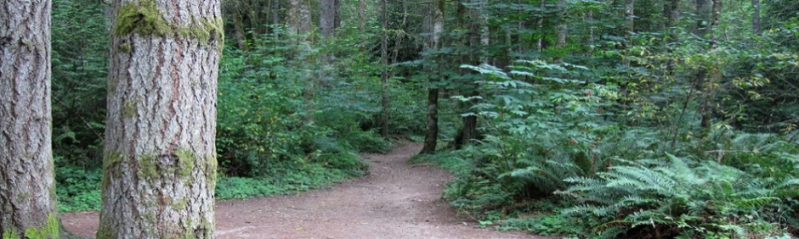**Work with transit providers to develop programs, routes and schedules that better accommodate a larger number of citizen moves.**
2. Identify the effective use of public transit in the design Silverdale districts and surrounding areas; especially the implementation of point-to-point shuttles and loop service, and service to high priority destinations.
3. Consider location of Park-and-Ride lots or similar facilities when making land use designations.
4. Develop priorities for Transportation Demand Management and Commute Trip Reduction, considering the home to work flow path for Silverdale workers.
5. **Improve safety and circulation for bicyclists and pedestrians.**
6. Establish priorities for completion of sidewalks and bicycle lanes in the design district areas.
7. Develop design standards for establishing pedestrian and non-motorized access that connect surrounding areas to the Silverdale Regional Center.
8. Develop and implement an off-street pathways plan for Silverdale to include walking paths, bicycle paths, and the trails system.
9. Encourage private sector development and maintenance of trails.
10. **Ensure that transportation facilities necessary for future growth are provided concurrent with growth and coordinated with the overall land use plan for Silverdale.**
11. Develop and maintain an effective transportation system for Silverdale and the surrounding areas.
12. Develop and implement an effective transportation concurrency system that provides effective transportation infrastructure to support concurrent land use in growth and development.
13. **Locate, design and construct transportation connections to the Greaves Way that facilitate coordinated access to commercial, business center and industrial zoned lands.**
14. Locate and develop connector roads for Greaves Way that provide access to surrounding properties. Coordinate with property owners on alignment alternatives and roadway design.
15. To maximize the use of Greaves Way, connector roads shall be delineated to provide free-flowing, multi-modal access to the commercial, industrial and
16. business properties in the area.
17. Establish connector roads’ location and design through amendments to the Silverdale design standards or Kitsap County Code. Such amendments shall allow for flexibility if property ownership is consolidated and an alternate location and/or design will meet the intent of the connector road system.
18. The connector roads shall be funded by private property owners or new development. Funding of these roadways may include, but is not limited to,
19. County Road Improvement Districts (CRID) and individual developer construction. If public funding is available for the development of this roadway network, monies and project scope should be identified in the 6-year Transportation Improvement Plan.
20. **Effectively coordinate with neighboring jurisdictions to establish and maintain an effective transportation system for Kitsap County and the West Sound region.**
21. Develop procedures for effective inter-jurisdictional coordination.

Capital Facilities

1. **Provide a park, recreation and open space system that enhances the quality of life for residents and visitors to the Silverdale community.**
2. Update the Kitsap County Greenway Plan to identify key pedestrian trails and greenways needed to link destinations in Silverdale.
3. Ensure that stormwater facilities provide adequate drainage and minimize flooding while protecting and enhancing the water quality and habitat value of streams, wetlands, lakes and Dyes Inlet.
4. **Provide efficient and convenient solid waste and recycling services to the Silverdale community through effective coordination with service providers.**
5. Coordinate with private solid waste collection services to ensure adequate service capacity for planned growth.
6. Encourage programs for yard and food waste composting, waste recycling, and reuse of building materials.

Silverdale Regional Center

• • •

Overall Vision for Silverdale Regional Center

The Silverdale Regional Center Plan (Plan) will guide the evolution of the Silverdale Regional Center from a collection of strip malls and office buildings into a more livable, sustainable and balanced mixed use urban area serving everyday essentials to residents, employees and visitors.  A regional growth center designation is acquired through the Puget Sound Regional Council and must include:

* A vision for the center that describes the role (economic, residential, cultural, etc.) of the center within the county and region;
* Clearly identifies the area designated as a regional growth center;
* Describes the relationship of the center plan to the County’s Comprehensive Plan, PSRC Vision 2040, and countywide planning policies; and
* Includes a market analysis of the regional growth center’s development potential.

Significant housing and job population increases over the next 20 years will drive this transformation. A key component of the Plan is channeling anticipated growth of Silverdale Urban Growth Area into the Silverdale Regional Center. This will protect the character and scale of Silverdale’s existing neighborhoods and create a vibrant urban community with convenient access to commercial activities and increase the number of jobs in the Silverdale core.

A Green Corridor Network linking major destinations, community and neighborhood parks, riparian corridors, tree lined streets, active and passive plazas and other shared urban spaces, is fundamental to the Silverdale Regional Center’s livability. Connectivity will be achieved by incentivizing mixed use developments and providing easy, safe and enjoyable pedestrian and vehicle connections to retail shopping, major public facilities, open space and other neighborhoods. A vibrant retail core and strong residential community can be sustained and enhanced by making pedestrian circulation a priority.

The Urban Community, Connectivity & Mobility, Environment, Economic Development and Housing Elements in this Plan lay the groundwork for urban density development that creates a sense of place, promotes an Active Transportation system for pedestrians, cyclists, transit and cars, and protects and includes the natural environment - all without sacrificing Silverdale’s existing character and vitality. The Silverdale Regional Center’s growth and transformation will not happen overnight. Amenities, such as the Green Corridor Network and capital investments in parks and transportation, will encourage and support the redevelopment of the Silverdale Regional Center.

Silverdale Regional Center Goals and Policies

Urban Community

Vision: Inspire a healthy, inter-connected urban community where pedestrians are priority, buildings and open space are openly inter-related, the site and design makes a positive contribution to the public realm, and ultimately, people are drawn to live, work and play.

*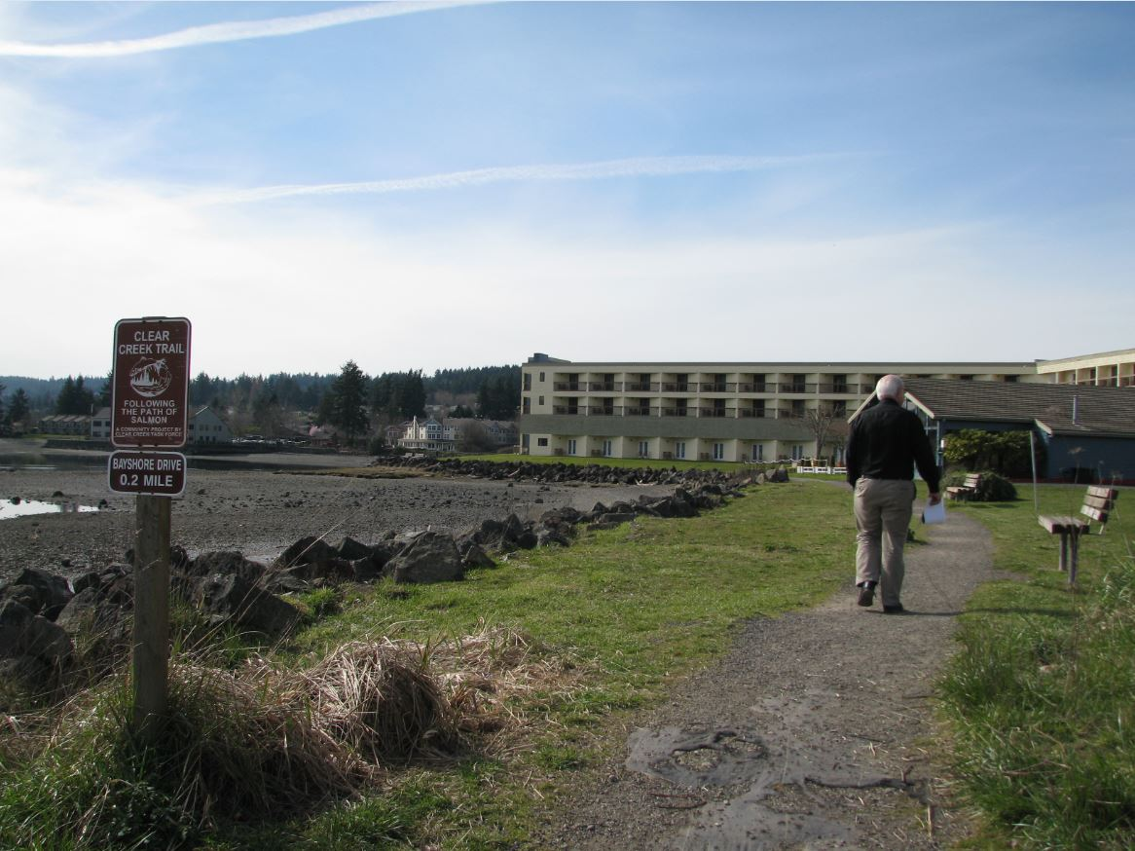***SRC Urban Community Goal 1. Create a compact, visually attractive, mixed use, urban community that prioritizes pedestrian safety and comfort and enhances the quality of life for all who live, work, or visit the Silverdale Regional Center.**

1. Meet the Puget Sound Regional Council requirements necessary to maintain the Regional Growth Center Designation for Silverdale.
2. Adopt and update development and design standards to promote pedestrian oriented development that ensures quality urban development.
3. Support redevelopment that is consistent with the Silverdale Regional Center Plan and related development and design standards.
4. Enhance the public perception of the Central Kitsap Community Campus (Campus) as a destination in the community by supporting mixed use development within it and pedestrian, bicycle, and transit connections to other public and private destinations within the Silverdale Regional Center.
5. Allow increased heights and densities and parking requirement reductions as incentives to provide frontage improvements, additional open space, multi-family or affordable housing, rooftop gardens, and energy and environmental design certifications.
6. Incorporate pedestrian, bicycle, and gathering space amenities into both site and building design elements.
7. Reduce the trip generation rate for projects that achieve urban densities or include bicycle facilities.

**SRC Urban Community Goal 2. Create a Green Corridor Network (see Green Corridor Network Map) with a web of interconnected parks, open space, and non-motorized trail systems that serve the needs of all Silverdale residents.**

1. Identify the Campus as a centralized destination in the community with regards to the Green Corridor Network and give priority to transportation projects that enhance multi-modal connectivity to the Campus.
2. Incorporate the needs and locations of vulnerable populations when making decisions with regards to the Green Corridor Network.
3. Improve the existing Clear Creek Trail network by supporting a public/private partnership to increase connectivity to surrounding uses. The trail shall be identified as key component of the Green Corridor Network infrastructure.
4. 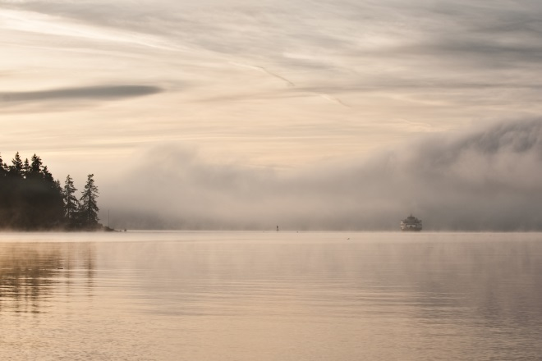 Improve the Non-motorized Routes and Parks. The expanded and improved system shall increase mobility within Silverdale, provide transportation benefits, emphasize recreational benefits and connect to the larger, regional land and water trail systems.
5. Re-prioritize park, open space and trail projects to ensure that Kitsap County invests in the Green Corridor Network.
6. Promote the development of Complete Streets and Green Streets throughout Silverdale.
7. Integrate natural features such as wetlands, riparian corridors and hillside views into site design as amenities and protect them as environmental resources.
8. Support development that includes low maintenance landscaping installations.
9. Develop mechanisms to maintain landscaping to ensure the long term success of the Green Corridor Network as the Silverdale moves from a suburban to urban development pattern.

**Urban Community Goal 3: Establish development standards based on urban, rather than suburban, densities and needs.**

1. Reduce parking requirements and increase building coverage allowance for developments that provide structured parking or support mixed use development.
2. Incentivize underground parking and bicycle facilities for new development or re-development projects.
3. Require an increased percentage of windows on the building story at street level.
4. Require that buildings be brought closer to the movement zone.

**Urban Community Goal 4: Measure progress towards implementing the Silverdale Regional Center Plan by regularly monitoring the type and amount of new development, capital investment and other mitigation measures and improvements made to accommodate growth.**

1. Following Silverdale Regional Center Plan adoption, prepare and present a five-year Silverdale Regional Center Monitoring Report to the Board of County Commissioners for review and consideration. The report shall provide statistical analysis of land and infrastructure development trends and patterns within the Silverdale Regional Center relative to the goals and policies of the Silverdale Regional Center Plan. The report may recommend changes to plans, policies and ordinances.

Connectivity and Mobility:

Vision: Create a more efficient multi-modal transportation system that supports an increasing number of people living, working, and visiting Silverdale and increases the ability to access destinations without the need for a personal automobile.

**SRC Connectivity and Mobility Goal 5: Reduce the share of trips made by single occupancy vehicles (SOV).**

1. Commit to a local and regional transit supportive and non-motorized component mode split.
2. Create urban centers that link with a high-capacity transit system, busses and other transit modes.
3. Implement transportation demand management and commute trip reduction strategies.
4. Promote transit ridership to reduce greenhouse gas emissions.
5. Collaborate with Kitsap Transit to improve the speed and reliability of transit service in Silverdale.
6. Expand the system of dedicated transportation facilities for pedestrians and bicyclists Non-motorized Routes and Parks that improve safety, comfort, and usability.
7. Implement actions to recognize Silverdale as a Bicycle Friendly Community.
8. Maintain a seamless, safe and convenient pedestrian and bicycle network.
9. Collaborate with Kitsap Transit to provide an alternative to SOV trips, including commute trip reduction, shared-vehicles (i.e. Zip Cars) and Bike Share.

**SRC Connectivity and Mobility Goal 6: Create a street system that supports the land use and transportation vision for the re-development of Silverdale.**

1. Modify the Transportation Improvement Program (TIP) to increase the potential for implementing projects located within the Silverdale Regional Center.
2. Establish a preferred block length and apply it to new development or re-development projects.
3. Improve all modes of transportation within the Silverdale Regional Center and provide transitions to regional connections.
4. Develop a hierarchy of importance for circulation facilities. Give strong consideration to:

* Character and aesthetics in the design and implementation of all street projects;
* Integration of open space and landscaping, including street trees;
* Sidewalk standards that promote pedestrian functionality and avoid obstructions;
* Protected, designated bicycle facilities;
* Ample curb space for future or expanded bus stops;
* Environmentally sensitive practices, including natural drainage systems, where appropriate; and
* On-street parking.

1. Establish and adopt criteria to prioritize the required improvements when circulation facilities are not able to be built in accordance with the specifications. In some cases, there may be extraordinary financial or physical barriers that require deviation from the Standards. Examples include critical areas, mature trees/landscaping, a building within the desired Right of Way, or the County’s inability to acquire Rights-of-Way at a reasonable cost.
2. Interconnect all modes of transportation within the Silverdale Regional Center circulation network.
3. 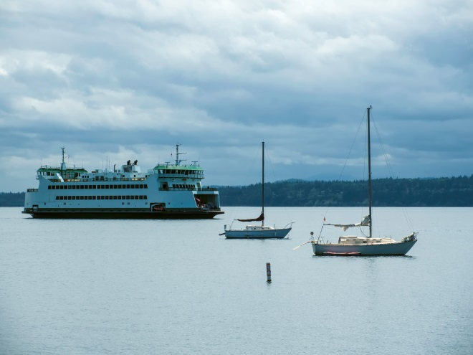Invest private and public funds in architecture and circulation facility design that supports transit choices such as transit facing entries, weather protection and pedestrian connections between buildings and community spaces, and transit stop spacing that supports fast, efficient transit.
4. Design and construct circulation facilities and streetscapes to be an inviting pedestrian environment that supports an urban community and a variety of transportation choices.
5. Improve circulation and access for persons with disabilities.

**SRC Connectivity and Mobility Goal 7: Invest strategically in transportation to achieve goals and policies within the Silverdale Regional Center Plan.**

1. Increase the percentage of annual transportation funding dedicated to sidewalks, trails and bike lanes by shifting funding from SOV motorized facilities.
2. Support a variety of mobility options to and from other communities.
3. Consider the health and equity impacts on vulnerable populations, including low-income, children and those with disabilities when locating facilities within the Active Transportation System.

**SRC Connectivity and Mobility Goal 8: Pursue the adoption of funding mechanisms to incentivize and support transit and multi-modal transportation trips.**

1. Modify impact fees to insure that development in the Silverdale Regional Center contributes its fair share to multi-modal transportation improvements.
2. Pursue a County Road Improvement District (CRID) and Utility Local Improvement District (ULID) options for the Silverdale Regional Center.

**SRC Connectivity and Mobility Goal 9: Improve mobility for all modes of transportation and create a gateway at Silverdale’s urban growth area or regional center edges.**

1. Partner with Washington State Department of Transportation (WSDOT) and local property owners to improve connections between arterial streets and state highways.
2. Create a wayfinding signage program with a priority on gateway signage.

Environmental:

Vision: Build a community that draws nature into this developing urban community, creates landscapes that restore both nature and human activity, and cares for and preserves the natural environment for ourselves and future generations.

**SRC Environment Goal 10: Improve stormwater quality and management.**

1. Coordinate stormwater detention and treatment as part of the larger regional stormwater system.
2. Incentivize development that improves stormwater quality and runoff flow control beyond minimum standards.
3. Protect healthy stands of prominent trees and plant trees within the Green Corridor Network to improve the tree canopy and aid in stormwater management in Silverdale.

**SRC Environment Goal11: Enhance wetlands and the riparian corridors to improve environmental functions and fish and wildlife habitat.**

1. Incentivize the restoration or rehabilitation of wetlands and riparian corridors as part of new development or re-development.
2. Encourage the development of boardwalks or walking paths in riparian corridors.
3. Connect natural areas to stream corridors and open spaces outside the Silverdale Regional Center.

**SRC Environment Goal 12: Create a sustainable community, consistent with Kitsap County’s Comprehensive Plan Sustainability Policies.**

1. Support projects that increase air quality, reduce carbon emissions, or reduce climate change impacts.
2. Establish a Sustainability Building Strategy for Silverdale. Maintain innovation as a keynote to the County’s sustainability efforts.
3. Encourage buildings and infrastructure in the public and private sectors which:

* Use less energy and have a lower climate impact;
* Use recycled water to reduce consumption of potable water;
* Are less toxic and healthier;
* Incorporate recycled, third party green certified, and locally produced materials;
* Reduce stormwater runoff;
* Provide wildlife habitat; and
* Use green building technologies, products, and processes.

**SRC Environment Goal 13: Develop greenhouse gas emissions reduction ratio targets and achieve them through land use, transportation, and commercial and residential building construction and site development strategies.**

1. Pursue an Energy and Climate Plan for Silverdale.
2. Emphasize mixed-use development in the Silverdale Regional Center so that people live in close proximity and have convenient access to goods and services, preferably within walkable distances.
3. Support the development of community gardens as a valid replacement for an open space requirement.
4. Support a multi-modal transportation system so that all people who live and work in the SRC have a variety of convenient low- or no-emission transportation options.
5. Establish a program to support energy efficiency retrofits of existing buildings which will not be redeveloped in the short term.
6. Work with Puget Sound Energy to expand participation in the Green Power Program.

**SRC Environment Goal 14: Develop Creek restoration, revitalization plans, and a Green Corridor Network plan in to guide new development and redevelopment.**

1. Retain existing trees in critical areas and their buffers, along designated pedestrian corridors and in other urban green spaces. Plant new trees consistent with the Silverdale Regional Center policies and standards recognizing their micro-climate, urban design and livability benefits.
2. Collaborate with property owners to ensure the completion of creek restoration or revitalization plans.
3. Develop management and implementation plans for the Green Corridor Network, including creek and trail restoration that actively addresses the current issues of garbage and safety on existing trail systems.

**SRC Environment Goal 15: Improve and expand the use of Transfer of Development Rights (TDR) to locate density adjacent to urban services while preserving developable open space or agriculture and forest lands.**

1. Identify the Silverdale Regional Center as a receiving site for the Transfer of Development Rights program.

Economic Development

Vision: Foster re-development through processes that balance flexibility and predictability, effective use of financial incentives, and cultivation of public/private partnerships that result in mutually beneficial solutions.

**SRC Economic Development Goal 16: Maintain Silverdale’s economic engine by accommodating and attracting a majority of anticipated job and housing growth for the Silverdale Urban Growth Area in the Regional Growth Center.**

1. Pursue a Planned Action Environmental Impact Statement (PEIS) for the Silverdale Regional Center.
2. Support the development of wayfinding signage program.
3. Phase development so that transportation, open space, and other infrastructure are in place or committed to serve the needs of growth.
4. Invest in infrastructure to encourage new development or re-development.
5. Require conduit and/or fiber to be installed as part of all street and utility projects that are at least one block in length.

**SRC Economic Development Goal 17: Educate the public about the benefits associated with the Silverdale Regional Growth Center planning efforts.**

1. Complete a market analysis for the Silverdale Regional Center.
2. Work with the Kitsap Economic Development Alliance to promote the Silverdale Regional Growth Center as a desirable destination to live, work, and play.

Housing

Vision: Nurture a community that accommodates a diversity of income levels, activities, amenities, open spaces, gathering places, recreation and mobility options that all contribute to a self-sustaining community where people aspire to live, work and play.

**SRC Housing Goal 18: Locate a majority of Silverdale Urban Growth Area housing growth in the Silverdale Regional Growth Center.**

1. Incentivize the development of higher density residential buildings in the Silverdale Regional Center. Examples of incentives may include an increased height allowance and/or reduced parking requirements for projects that commit to frontage improvements, affordable housing provisions, senior housing provisions, additional open space provisions, and design elements provided to support multi-modal transportation.
2. Streamline and customize regulations to fit the particular needs of infill and redevelopment. Regulations shall reduce barriers and provide incentives to foster infill and higher intensity development.
3. Monitor housing creation to ensure that the SRC area housing targets are being achieved. Identify additional steps to spur housing development if monitoring shows the housing goals for Silverdale are not being achieved.

**SRC Housing Goal 19: Incentivize the development of affordable housing for persons of low and moderate income.**

1. Adopt regulations that incentivize affordable housing in all developments within the Silverdale Regional Center.

llahee

• • •

Vision for Illahee

The Illahee Community Plan is a statement reflecting the civic pride and community involvement that has existed for more than 120 years. The community shares a proud sense of accomplishment in all the current happenings: salmon restoration projects (1994-98), a new culvert (1999), the recent establishment of the Illahee Preserve (2003), and grants to improve conditions in the Illahee Creek watershed (2005/6/7). More importantly, many residents share a real concern for the future of Illahee if they and their neighbors are not actively and materially involved in the planning process. Many of the local citizens recognize that what originally attracted them to this area and what keeps them here is now threatened. This planning process allows them to continue to make improvements to further enhance the atmosphere and character of the area, ensuring that it remains the unique community they know and love.

When posed with the question, “What would you like to see addressed in a community plan?” residents envisioned a community centered around and amongst the abundance of natural resources in the area, which include Illahee State Park, Illahee Creek, and the Illahee Preserve; three miles of pristine waterfront; two major docks; and much more. Citizens want to maintain the community charm and quaintness that Illahee currently offers. Residents wish to protect the unique quality of the natural environment, park areas, wetlands, streams, and wildlife habitat. Residents also recognize the need to sustain the community connectedness and to accommodate reasonable growth in the area. These visions and dreams can be accomplished by permitting growth in those areas where infrastructure enhancements already exist and environmental protections are ensured. This also means securing open space designations for the natural resources that need protection and, especially, those already specified as park or preserve. It is this mix of land uses that makes the Illahee area a unique blend of natural resources and open space surrounded by semi-rural areas, urban areas, and a short perimeter of a commercial business strip along State Highway 303. Illahee is an area blessed with a diversity of natural and man-made resources. Residents desire a community plan that blends the best of these worlds into a place where they can continue to live in harmony with nature and their fellow citizens.

Illahee Goals and Policies

**Illahee Goal 1. Formalize a communication process between Kitsap County and Illahee Community Groups.**

1. Notify Illahee community groups that request notice of proposed land use actions and zoning changes within Illahee.
2. Support the continuation of an Illahee Community Citizens Advisory Group (CAG) to represent the citizens of Illahee in furthering the Plan’s goals and policies.

Environment

**Illahee Goal 2. Maintain current zoning that allows for protection of the environment.**

**Illahee Goal 3. Protect Illahee’s existing views of Mount Rainier, the Cascade Mountain Range, Bainbridge Island, Puget Sound, and the Seattle Skyline.**

1. Utilize the View Protection Overlay Zone for the Illahee community.

**Illahee Goal 4. Promote Safety and views by burying all utilities where applicable.**

[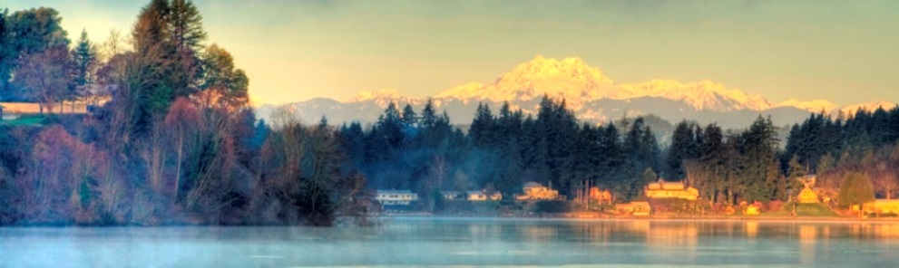](http://compplan.kitsapgov.com/MainSlider/Forms/DispForm.aspx?ID=1&RootFolder=/MainSlider)

1. Support the coordination of burying utilities during the planning phases of new road works in locations where views are obstructed or safety is compromised by utilities.

**Illahee Goal 5. Protect and restore the riparian areas of Illahee Creek and its estuary.**

1. Use infiltration as a method of stormwater, flow control, within the Illahee Creek Aquifer Recharge Area.
2. Evaluate solutions outside of using culverts for Illahee Creek that allow for the natural meandering of the creek and maintains/restores the accretion delta floodplain.
3. Coordinate the restoration of floodplain habitat and estuary function at the mouth of Illahee Creek.

**Illahee Goal 6. Enhance efforts to protect the biological diversity and habitats of fish, birds, wildlife, and plant life within the Illahee community.**

1. Continue identify and map wetland areas within Illahee as funding allows.

**Illahee Goal 7. Conserve the scenery and natural and historic trees within the Illahee community.**

1. Maintain minimum 25 foot natural vegetative buffers between development and roadways wherever possible.

**Illahee Goal 8. Continue efforts to preserve open space, wildlife corridors, habitat, stream health, and recreation opportunities, and support the implementation of the Illahee Forest Preserve Stewardship Plan.**

1. Support the pursuit of grant monies to complete purchases or conservation easements within the Illahee Creek corridor as outlined in the Illahee Preserve Stewardship Plan, including target properties in the Illahee Creek Watershed, and the “Heart of the Park” properties.
2. Support the pursuit of grant monies for the conservation of the undeveloped properties along Illahee Road between Illahee Creek and Trenton Ave. which are coincident with the Illahee Greenbelt, Wildlife Corridor, Mosquito Fleet Trail Scenic Byway, and proposed multimodal regional trail.

Transportation

**Illahee Goal 9. Address Illahee’s pedestrian thoroughfares to provide safe multimodal transportation options in and out of the community.**

1. Examine, and if feasible, create a safe multimodal transportation option for Illahee Road
2. Examine, and if feasible, create a safe multimodal transportation option along Oceanview Blvd/East Blvd and McWilliams from Illahee Road to SR 303
3. Examine, and if feasible, install a round-a-bout at the oblique 3-way intersection of Illahee Road, Oceanview Blvd, and Allview Blvd.

**Illahee Goal 10. Support the hydrological studies of well systems around Illahee Creek to determine the appropriate boundaries around the creek to ensure base flow levels in the creek are maintained.**

1. Support State agencies to begin a water balance monitoring system comparing base flows in Illahee Creek with draw down rates of local wells.

**Illahee Goal 11. Support the redevelopment of the intersection of Illahee road, Oceanview Boulevard, and the Illahee Community Dock into a community focal point.**

1. Facilitate the planning and construction of a community center at this location, which may also support a business.
2. Facilitate the planning and construction of a marine park at this location.

Keyport

• • •

Vision for Keyport

Keyport is a rural, historic waterfront village bounded and limited in size by its natural borders of water and the Naval Undersea Warfare Center. The community consists primarily of single family homes, a few small businesses, and a community park system. The community is close-knit, where people know and greet their neighbors, and has an active community club which provides social events. The Keyport community wants to limit urban growth to retain its sense of community and small-town ambience. Keyport citizens would prefer that future business expansion would be limited to small businesses and services serving the community, consistent with historical usage located near the downtown core.

The Keyport community desires to reestablish certain historic commercial zoning and to establish appropriate land use zoning to maintain historic rural character where it is consistent with historical public services. The community would like to establish development patterns, including lot sizes, which may encourage infill development consistent with the Growth Management Act.

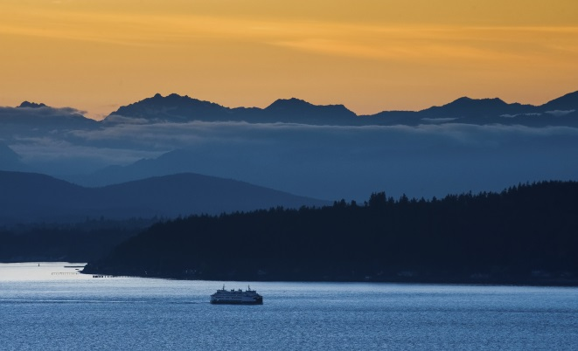

These infill development patterns would be consistent with historical progressive development, yet limit urban-like sprawl and high density growth. The Keyport community would like to improve existing transportation infrastructure and services to make it easier and safer to get around the community, make the community more pedestrian friendly, and improve parking for visitors. Improvements would be requested from Kitsap County as feasible to improve public infrastruc ture and facilities, including expansion of the sewer lines, upgrading the storm water drainage system, improving street lighting, and improving marine access.

The community would like to retain a flexible community park system attractive as gathering and recreational centers for both children and adults. Keyport citizens would like to preserve and enhance the small-town atmosphere and visual character of the area for the community as well as visitors, where one can enjoy a safe and pleasurable walk, enjoy the spectacular marine and mountain views, and have easy access to a village center that acts as a social center with restaurants and services providing for basic needs.

Keyport Goals and Policies

Land Use and Economic Development

**Keyport Goal 1. Protect and enhance the Keyport Village character.**

**Keyport Goal 2. Provide zoning that is consistent with Keyport’s existing built environment and lot sizes that allow for beneficial infill development.**

1. Set minimum lot sizes, setbacks, heights, and densities for residential development.
2. Require application of Design Standards for all new commercial development in Keyport.

**Keyport Goal 3. Encourage property owners to cluster newly subdivided lots.**

1. Reevaluate the historical density bonus for all future clustered developments in the Keyport Village Low Residential (KVLR) zone.

**Keyport Goal 4. Promote the establishment and support of a vital Keyport Village Commercial zone.**

1. Establish a commercial zone appropriate for the population and transportation network of the Keyport Village.
2. Promote businesses that further the economic vitality of Keyport as a “destination”.

**Keyport Goal 5. Encourage mixed-use development within the commercial zone.**

1. Modify County parking requirements to levels appropriate for the Keyport Village.
2. Encourage the development of design standards for the Keyport Village Commercial zone.
3. Allow increased height limits for structures within the Keyport Village Commercial zone.

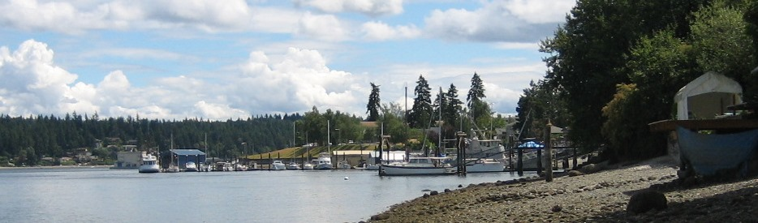**Keyport Goal 6. Protect Keyport’s existing views of the Olympic mountain range, Liberty Bay, Dogfish Bay and Puget Sound.**

1. Encourage development that creates the least impact to existing views.

**Keyport Goal 7. Archaeological, cultural, and historic structures or places are an important community asset, are a part of Keyport’s character, and should be identified, evaluated, and preserved.**

1. The Keyport community, in conjunction with the Poulsbo historical society, should identify and seek funding to institute a historic survey, implement a local, historic registry program and/or the creation of a landmark commission.
2. If feasible, the County should consider the implementation of a local historic preservation ordinance.

**Keyport Goal 8. Historic structures or places are an important feature of community design and should be preserved and enhanced.**

1. Design Standards should be implemented for design of projects adjacent to a historic structure to ensure that new development is compatible with the structure and that its surroundings are preserved.

Transportation and Pedestrian Improvements

**Keyport Goal 9. Encourage development of an efficient multimodal transportation system and develop a funding strategy and financing plan to meet its needs.**

1. Future Washington State Route 308 Improvements should consider the use of separated, continuous, 5- foot paved bicycle / pathways for pedestrian use. These walkways shall be coordinated with the Mosquito Fleet Trail Plan as necessary.
2. Developments abutting County rights-of-way within the Keyport Village Commercial zone should include sidewalk construction.
3. Set minimum lot sizes, set backs, heights, and densities for residential development.
4. Require application of Design Standards for all new commercial development in Keyport.

**Keyport Goal 10. Provide the citizens the opportunity to participate in the development of transportation planning policy.**

1. Encourage Keyport citizen participation, organizations or individuals, in County and State transportation planning efforts within or adjacent to the Keyport Village.

**Keyport Goal 11. Reduce accidents and potential accidents by providing a safe transportation system through good**

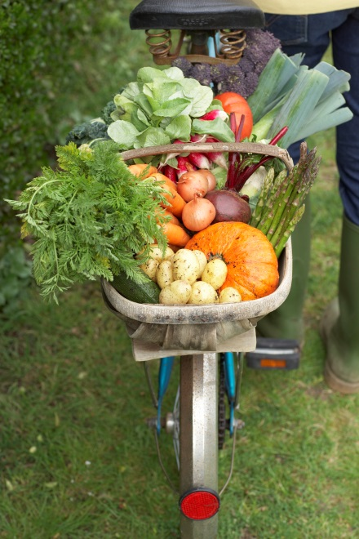**design practices.**

1. Analyze accident data to determine where safety–related improvements are necessary. Prioritize and implement safety-related improvements during the transportation planning process.

**Keyport Goal 12. Minimize negative environmental impacts by the transportation system.**

1. Maintain environmental standards and mitigation requirements that are the same or higher than those placed upon the private sector, especially adjacent to or upstream from salt-water marine environments.

Public Facilities and Infrastructure

**Keyport Goal 13. Encourage expansion of the existing sewer distribution system to all properties within the Keyport Limited Area of More Intense Rural Development boundary.**

1. Encourage all new construction and remodel projects involving an increase in sewage beyond the existing capacity of the septic system to connect to sewer if within 200 feet of an existing line.
2. Immediately address failed septic systems.
3. Encourage property owners on shorelines or near other critical areas to connect to the sewer system.
4. Consider establishing a Local Improvement District for properties west of Sunset Avenue.

**Keyport Goal 14. Encourage enhanced Library Services in Keyport.**

1. Work with Kitsap Regional Library to encourage regular service of the Kitsap Regional Library Bookmobile within Keyport.

Port Improvements and Waterfront Development

**Keyport Goal 15. Work with the Port of Keyport to encourage expansion of the existing Port of Keyport Facilities.**

1. Work with the Port of Keyport to update the Port of Keyport Master Plan.
2. Work with the Port of Keyport to identify specific projects for a Port of Keyport funding measure.
3. Work with the Port of Keyport to research grant opportunities for shoreline improvement or replacement of marine facilities.

**Keyport Goal 16. Minimize additional private docks in Keyport.**

1. Encourage joint use docks for any new dock development.

Natural Environment / Parks and Recreation

**Keyport Goal 17. Protect, restore, and enhance the natural and shoreline resources that add to the unique character of the Keyport Village.**

1. Encourage permanent preservation of lots with significant critical areas or wildlife habitat.
2. Work with the Kitsap Health District to monitor private septic systems and immediately respond to any failed system within Keyport that may flow into Dogfish Bay or Liberty Bay.
3. Encourage the replanting of native tree and plant species on all properties, especially those publicly-held.
4. Encourage creation of natural greenways, vegetated pathways, backyard natural habitat corridors, and street plantings.

**Keyport Goal 18. Maintain current public facilities, parks, and port facilities, and add new facilities when determined by the community.**

1. Coordinate with the Keyport Village community on any development plans for public facility improvements and additions.
2. [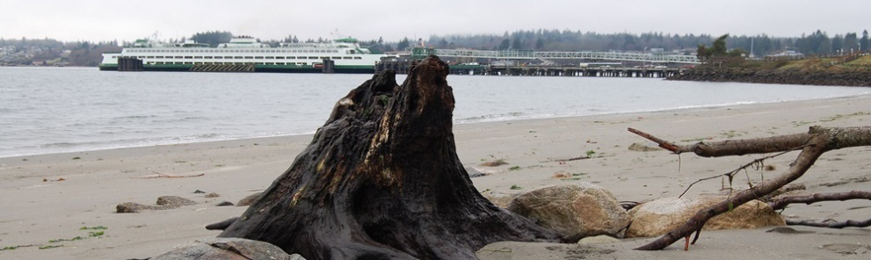](http://compplan.kitsapgov.com/MainSlider/Forms/DispForm.aspx?ID=15&RootFolder=/MainSlider)Pursue creative funding strategies, grants, and opportunities to leverage federal, state, local, and volunteer sources for maintenance and capital improvement budgets.

**Keyport Goal 19. Provide facilities to serve the variety of ages and needs in the community.**

1. Explore the planning and construction of a community center within the Keyport Village boundary.

Arts and Culture

**Keyport Goal 20. Encourage local support for a creative and economic environment that allows artists to continue to live and work in and for the community.**

1. Create a stimulating visual environment through the public and private artworks programs, and create a greater understanding and appreciation of art and artists through community dialogue, education and involvement.
2. Advocate for the inclusion of quality public art in projects built by both private developers and public agencies, promote quality design in both the natural and built environments and use artists on design teams

**Keyport Goal 21. Preserve and share the community’s unique setting, character, history, arts and culture by developing partnerships, resources and attractions that respect the needs and desires of Keyport residents.**

1. Identify and record Keyport’s “Sense of Place” through a continuous public dialogue about the influence of the arts, history, and culture.
2. Use artistic, historic, and cultural events as vehicles for sharing Keyport’s uniqueness with residents and visitors while cultivating partnerships among the local artists, organizations and those interested in the arts, economic development, tourism, and historic preservation.
3. Identify local artists and publicize their value to the community through opportunities for public dialogue, and online database, and directory of artists, and residency programs, with support through non-profit organizations.

Sustainability

**Keyport Goal 22. Encourage sustainable practices and green building in Keyport.**

1. Implement Low Impact Develop Standards for Keyport Stormwater development and improvements.
2. Promote Solar, Wind, Tidal, Wave Generation and other renewable energy generation infrastructure to serve the Keyport Community.
3. Promote installation of energy efficient fixtures (both electric and water based)
4. Promote U.S. Green Building Council’s; Leadership in Energy and Environmental Design (LEED) silver certification standards for all future public buildings in Keyport.

Community Building and Plan Implementation

**Keyport Goal 23. Foster an environment that supports the active and meaningful involvement of the community in local,**

**county-wide and regional issues.**

1. Ensure that Keyport residents have access in the community to information regarding future land uses and activities.
2. Encourage the support and maintenance of the Keyport Improvement Group to represent the citizens of Keyport in furthering of the Plan’s goals and policies.